
Lab 6: Explainability and Text Mining

Part I:
Explainability is essential for convincing users to use Machine Learning models and also for understanding those models. Orange Data Mining comes with a very nice add-on called “Explain 0.6.1” for explainability that is able to give useful insights about the models.

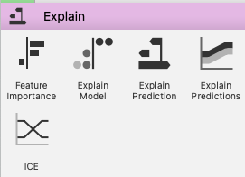

You can see a full tutorial of this addon in the following video: https://youtu.be/InPKf_dlo1A

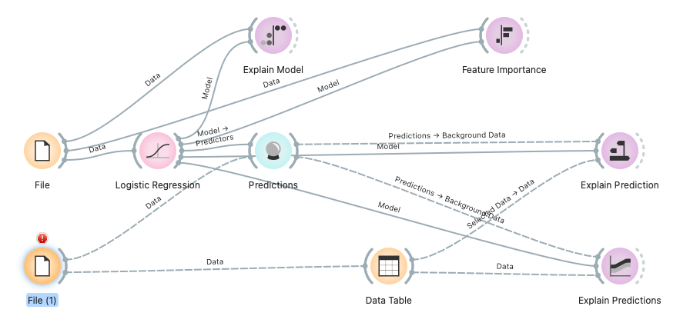

For practicing this exercise, you can download the databases from:
https://github.com/HussamHourani/HussamHourani/blob/Orange-Datamining/English/iris.tab
https://github.com/HussamHourani/HussamHourani/blob/Orange-Datamining/English/iris%20for%20Test.tab

Part II:
Text Mining is a very important part of Data Mining as most internet content is unstructured and has different dimensions. During classes, we have seen different techniques you can use to classify documents such as “Bag of words” or “Word Embedding”.
Let’s start with the “Bag of Words” which first creates a table with all the different words and counts the frequency each document has. Then, it counts the number of words each document has so it can be represented as an array rather than using the whole document.
To start practising with Text Mining there is a very interesting add-on in orange called “Text Mining”. You will need to use the different plugins to create clustering (grouping similar documents), classification (predicting the topic of the articles), and so on.
To do this there is a sequence of videos by Hussam Hourani. Videos from 46 to 49 are about the main things you can do with a group of documents.
46 :Text Mining : Text and Corpus

Example of a pipeline for classifying documents using Bag of Words:

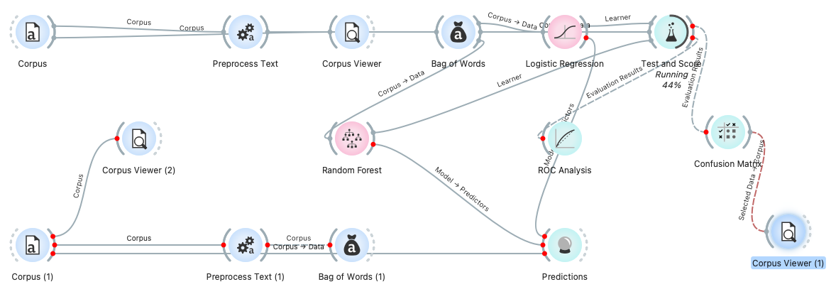

Example of a pipeline for classifying documents using Word Embedding:

